# Chapter 5: Data Model

In this chapter we will discuss about the data models of our system.

## 5.1 Data Modeling Concept

If software requirements include the need to create, extend, or interface with a database or if complex data structures must be constructed and manipulated, a software team may choose to create a data model as part of overall requirements modeling.

## 5.2 Data Objects

A data object is representation of composite information that must be understood by software. Here, composite information means that has a number of different properties or attributes. A data object can be an external entity, a thing, an occurrence, a role, an organizational unit, a place or a structure.

### 5.2.1 Identify Data Objects

Nouns having attributes are selected as data object. Those who doesn’t have any attributes have covered under the data objects.

**Data Object:** User

**Attributes:**

* User id
* Password
* First Name
* Last Name
* Email
* Mobile No.
* Role id
* Present Address
* Permanent Address
* Picture

**Data Object:** Student

**Attributes:**

* Student id
* User id
* Registration No.
* Session
* University
* Department/Institure

**Data Object:** University

**Attributes:**

* Id
* Name
* Location

**Data Object:** Course

**Attributes:**

* Id
* Name
* Semester No
* Credit

**Data Object:** Semester

**Attributes:**

* Id
* Name
* University

**Data Object:** Marks

**Attributes:**

* Id
* Student id
* Course id
* GPA

**Data Object:** Department

**Attributes:**

* Id
* University
* Name

**Data Object:** Stackholder

**Attributes:**

* Id
* Name
* Institute
* Email
* Designation
* Country

**Data Object:** Verification

**Attributes:**

* Id
* Student id
* Stacholder id
* Verification Status
* Digital Sign

**Data Object:** Log

**Attributes:**

* Id
* User id
* Operation
* Location
* Table Row

**Data Object:** User Activations

**Attributes:**

* Id
* User id
* Token
* Created At

**Data Object:** Registrar

**Attributes:**

* Id
* User id
* University id

**Data Object:** PO

**Attributes:**

* Id
* User id
* Department id

*5.2.3 Entity Relationship Diagram*

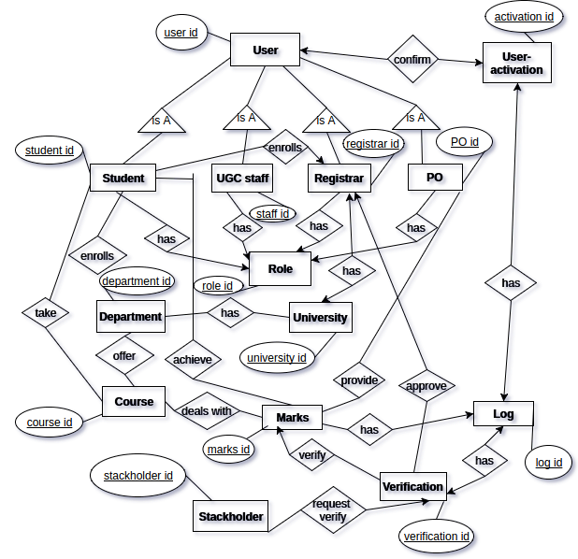

*Figure 18: ER Diagram for data based modeling*

In above diagram, only one primary keys are mentioned for each data objects.